**Practical No. 3:**

**Grey Level Slicing**

%Dnyaneshwari Jyprakash Ekhamde

%Roll No. 31132

x=imread("C:\Users\kulso\Desktop\cameraman.png"); y=x; [w h]=size(x); for i=1:w for j=1:h

if x(i,j)>100 && x(i,j)<=200 y(i,j)=255; else y(i,j)=0; end end end figure,imshow(x); figure,imshow(y);

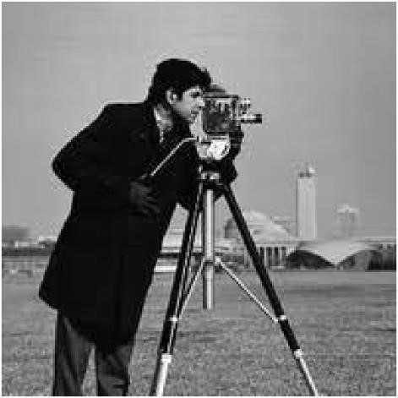

Bit Plane Slicing

%Dnyaneshwari Jyprakash Ekhamde

%Roll No. 31132

A=imread("C:\Users\Admin\OneDrive\Desktop\123456.jfif");

[row,col]=size(A);

subplot(3,3,1), imshow(A), title('Original Image');

C=zeros(row,col,8);

for k=1:8

for i=1:row

for j=1:col

C(i,j,k)=bitget(A(i,j),k); %Bit slicing

end

end

subplot(3,3,k+1), imshow(C(:,:,k)), title(['Bit Plane ',num2str(k-1)]);

end

OUTPUT

